Assignment 1
STAT-540
Bruno Cavagnaro

- We set 𝑇 = 3, 𝑆0 = 100, 𝑢 = 1.2, 𝑑 = 0.8, 𝑝𝑢 = 0.7, 𝑝𝑑 = 0.3 and, for computational simplicity, 𝑅 = 0. We now consider a particular contingent claim, namely a European put on the underlying stock. The date of expiration of the option is 𝑇 = 3, and the strike price is chosen to be 𝐾 = 110. Show that this particular claim can be replicated and compute the hedging portfolio at each node. (One needs to make a chart like Fig 2.10 in the textbook, which can also be found in page 48 of LN1 slides.)

Answer:

$For T=3, S_{0}=100, u=1.2, d=0.8, p_{u}=0.7, p_{d}=0.2, R=0 \& K=110$

First step, is to build the stock price tree:
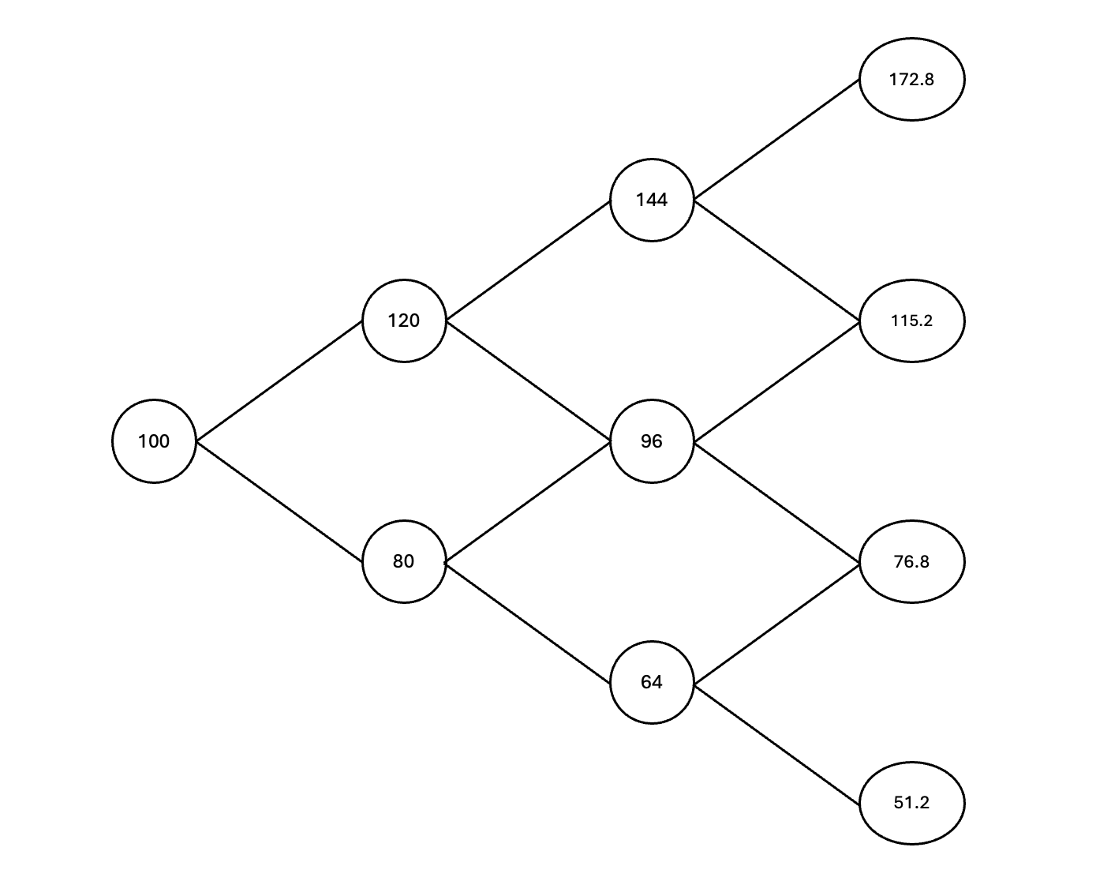
Step 2 is to calculate the price of the claim (considering that is a pull option, so the calculation would be: $X=max⁡[K-S_{T},0]$ ). Then we can use backward induction to find optimal values. Consider that the values of $q_{u}= \frac{\left(1+R\right)-d}{u-d}= \frac{\left(1+0\right)-0.8}{1.2-0.8} = 0.5 , q_{d}= \frac{u-(1+R)}{u-d}= \frac{1.2-1}{1.2-0.8}$ = 0.5. And the backward induction follows the following equation:
$$\frac{1}{1+R} \left[ϕ\left(u\right)*q_{u}+ϕ\left(d\right)*q_{d}\right]$$

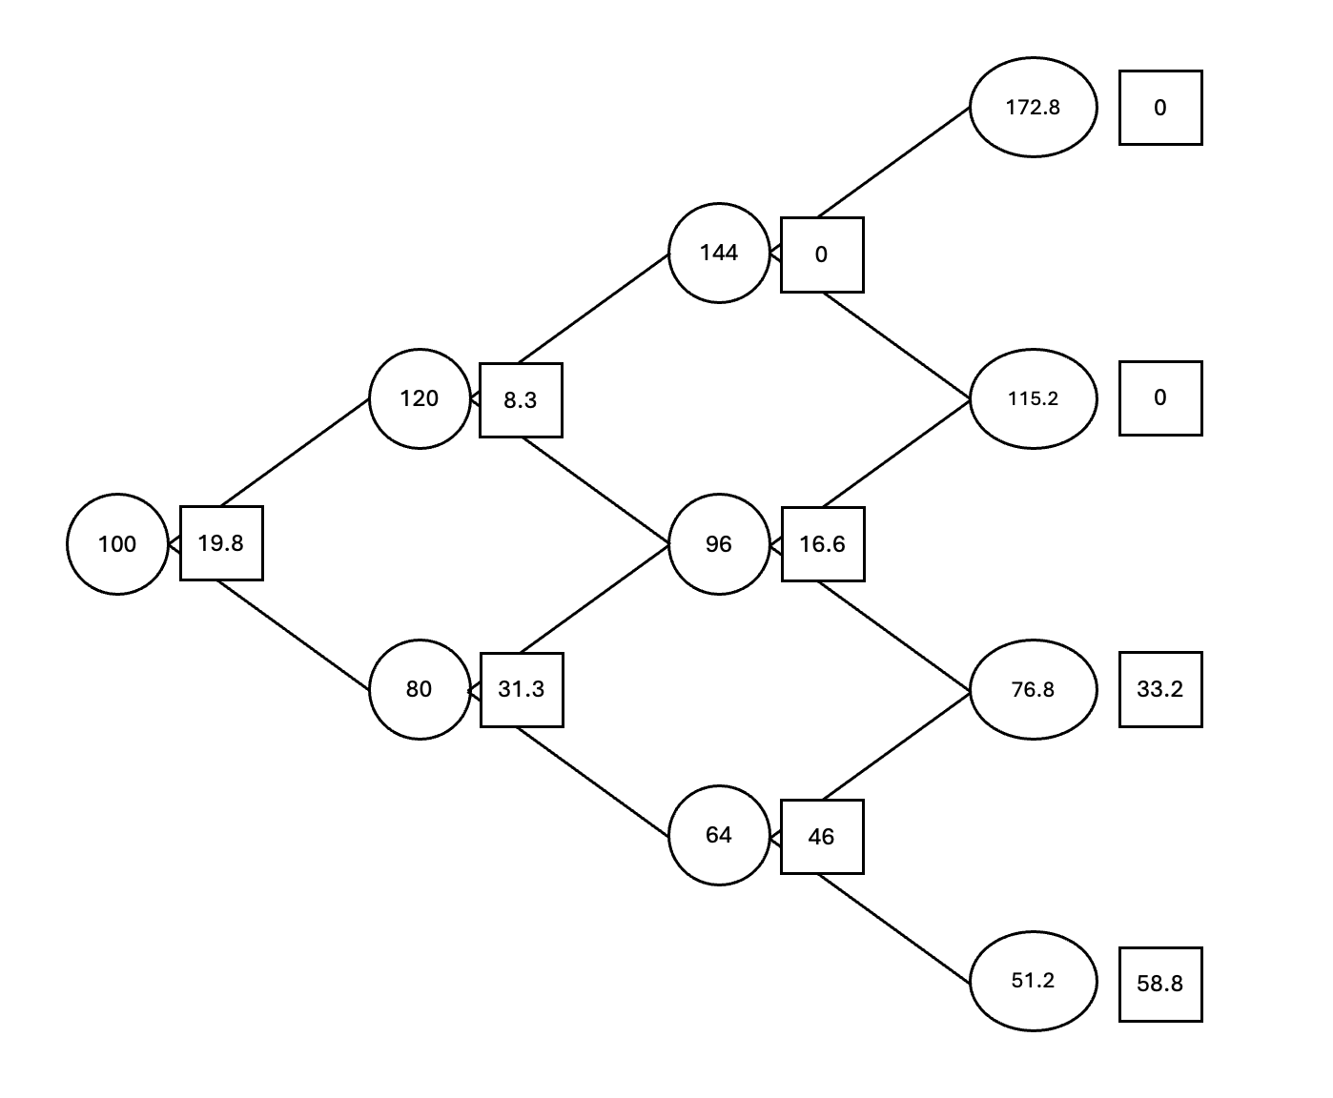

Step 3 Compute the hedging portfolio at each node:
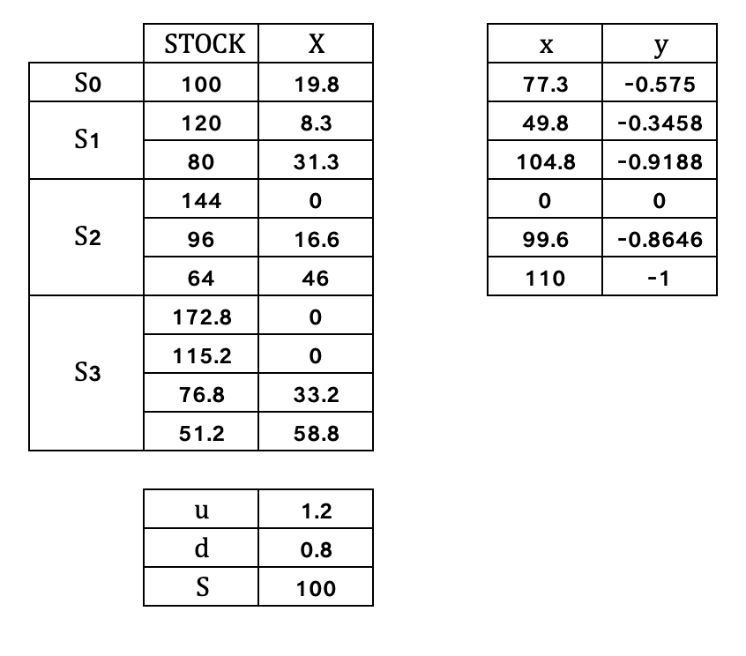

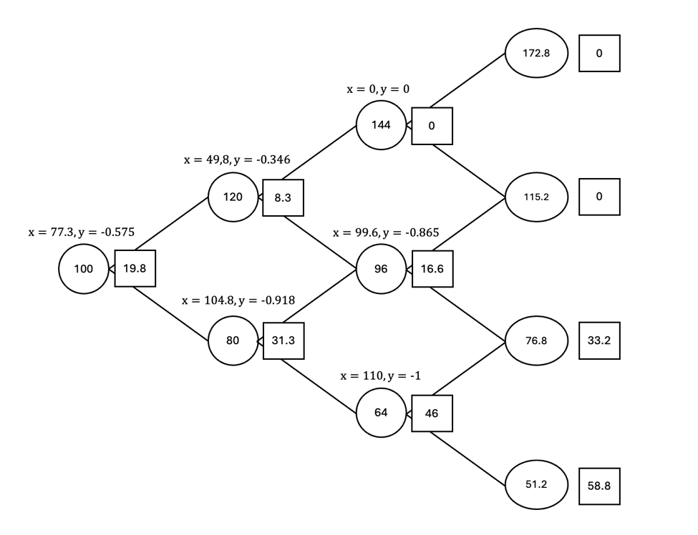

- Consider the multiperiod example in the text. Suppose that at time 𝑡 = 1 the stock price has gone up to 120, and that the market price of the option turns out to be 50.0. Show explicitly how you can make an arbitrage profit.

Answer:
Considering the results from above, the fair value of the option at node (u) where S1 = 120, V1(u) = 13.1. The option is severely overprice in the market. So the arbitrage strategy is to SELL the overprice option and hedge with the replicating portfolio.

- At t=1(stock price = 120):
  - Sell 1 put option at market price: +50 (cash in-flow)
  - Create the replicating portfolio to hedge our short position: from previous calculations: sell -0.3458 shares (41.5 inflow) and invest 49.8 in bonds (outflow)
  - Net cashflow: 50 + 41.5 – 49.8 = 41.7
- At t=2 we must rebalance the hedge:
  - Up:
    - Close short position: buy back the 0.3458 shares at 144 (-49.8)
    - Close bond position: +49.8
    - Net cashflow: 0
  - Down:
    - Net portfolio value: 49.8 + (-0.3458*96) = 16.6
    - Rebalance to hedge stock = -0.865 and 99.6 bond
    - Aditional short stock: -0.5188 (-49.8), aditional investiment in bonds (99.6 – 49.8 = 49.8)
    - Net cashflow = 0
- At t = 3:
  - Up-Up:
    - Stock value = 172.8, so option is worthless. Net cashflow = 0.
  - Up – Down:
    - Stock value = 115.2, so option is worthless. Net cashflow = 0.
  - Down - Up:
    - Stock value = 115.2, so option is worthless, put pay-off is 0.
    - Portfolio: Stock (-0.8646*115.2=-99.6) and bonds = 99.6.
    - Net cashflow = 0
  - Down – Down:
    - Put pay-off: 110 – 76.8 = 33.2 (we must pay)
    - Portfolio: short-stock (-0.8646*76.8 = -66.4), bond value (99.6), net portfolio value: 33.2
    - Net cashflow = 0
- Total arbitrage profit: 41.7

